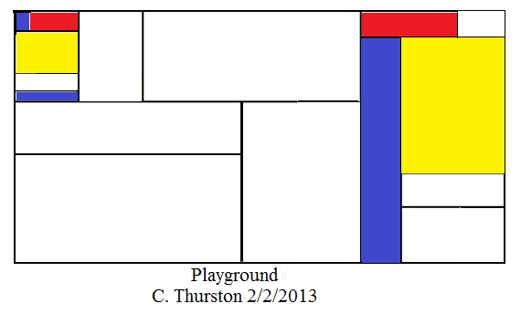

I utilized recursion to create this piece of Mondrian art because the creation followed a pattern, according to the rules set forth that govern the line placement being parallel and perpendicular, with colors in opposite corners and only primary ones used. In this way, a program to generate Mondrian art could be created mathematically to ensure that lines are placed parallel or perpendicular to one another, that there is no apparent symmetry, etc. Such programs do exist, but generally do not diminish the accomplishments of human artists; any piece of art can be enjoyed, whether or not a computer can also create a similar piece.

On the index card, you probably wrote a request that each person state their position in line, which would be one more than the person before you. You would have started this process, handing the person in front of you the card stating “I am the first person in line.” In this way, when the card makes it back to you, you would only have subtract one from it and divide by two to find out how many people are in line.

PMR:

I enjoyed creating the Mondrian art piece above, and would like to continue creating Mondrian art in the future—especially if I can write a program to generate it by using recursion!